Master thesis in RNA modification biology 31. October 2022
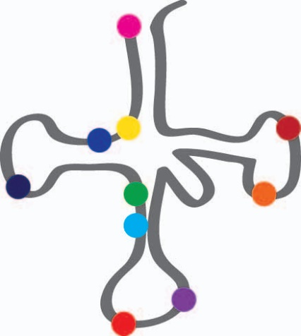
To date, more than 150 natural RNA modifications have been identified. However, the function and interplay among RNA modifications remains enigmatic. The Vilardo lab investigates RNA modifications in tRNAs, the key adaptor molecules between gene expression and protein translation. We use biochemistry, genome editing by Crispr/Cas9, and Next Generation Sequencing to investigate tRNA modifications and the enzymatic pathways responsible for modifications.
As part of the special research focus program RNA-Deco, we collaborate within a network of top RNA research laboratories across Austria.
If you are a highly motivated student in biology, biotechnology or similar subjects, and are interested to join our group at the Center for Anatomy and Cell Biology of the Medical University of Vienna, please send curriculum vitae, motivation letter and a recommendation letter to:
elisa.vilardo@meduniwien.ac.at

