Research technician position (40 h) 31. October 2022
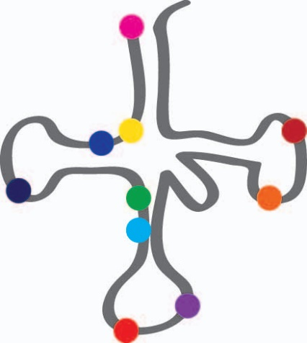
The group of Elisa Vilardo at the Center for Anatomy and Cell Biology is recruiting a Technical Assistant. The group works on the biology of tRNA modification, its impact on cell physiology and its implication in human disease. The projects involve the use of a diverse array of techniques, including tissue culture, molecular biology and biochemistry. We offer a young and international working environment within the frame of the Medical University of Vienna, located at the very heart of the city.
The ideal candidate will have a degree in biology, chemistry or related fields, and will be highly motivated to perform research in the life-sciences with the highest standards. Previous experience in cell and molecular biology is welcome, although further training will be provided in house as needed for the projects. The working language at the institute is English; knowledge of German will be of advantage.
The perspective start date is December 1st 2022.
If you are interested, please send a cover letter, CV, and two reference letters to elisa.vilardo@meduniwien.ac.at

